Identify the EUROPEAN and NORTH AFRICAN THEATERS battles on the following map:
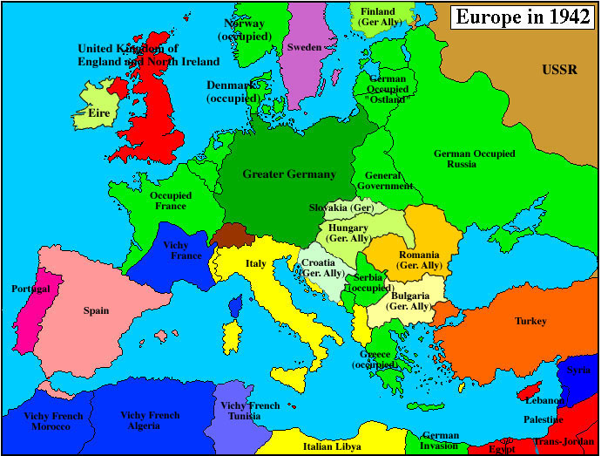

Identify the PACIFIC THEATER battles on the following map

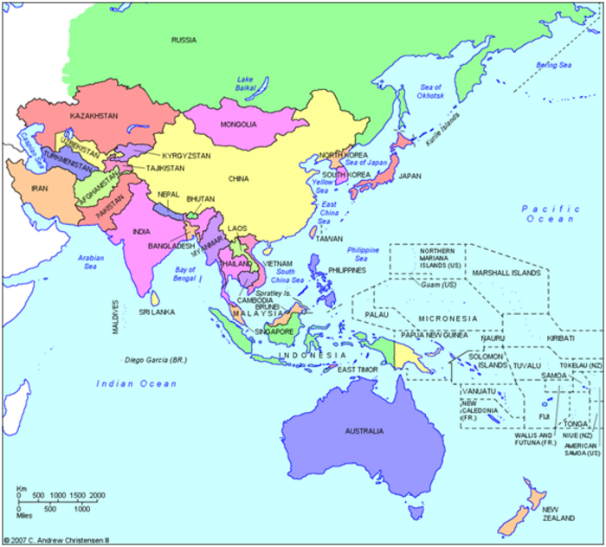
Name:________________________________________________________________Per:________Date:__________________________________________________
Identify the following people from WWII by explaining WHO they are and their SIGNIFICANCE to WWII

J. Robert Oppenheimer:

Albert Einstein:

Harry S. Truman:

Audie Murphy:

Dwight D. Eisenhower:

Rosie the Riveter:

George S. Patton:
Hideki Tojo:

Douglas MacArthur:

Admiral Yamamoto:

Winston Churchill:

Benito Mussolini:

Adolf Hitler:

Joseph Stalin:

