U.S. History Final Project: The Presidents

To review the big picture ideas from this year, you will create and present a project in small groups. You will chose a topic and create either a MUSIC VIDEO, BOARD GAME, or a MAGAZINE to present your information.

Music Video
Create a music video that discusses information from a particular president. You will need to…
- Create a song with lyrics that teach about one of the presidents (you may adapt a song that already exists OR write an original song)
- Write the lyrics for your song and turn in a copy
- Song should be 2-3 minutes in length
- Create a music video to go along with your song. The music video should go with the song and show images or have you acting out scenes from the time period (period dress costume is recommended!)
- The music video and song should be emailed or given to Ms. Holloway by the due date (hollowayja@svsd410.org)
- For great ideas, check out these music videos: http://www.youtube.com/user/historyteachers

Board Game
Create a board game themed around a particular president. You will need to…

- Create a game board using color and pictures from the time period
- Create a name for your game
- Create rules for your game
- Write out a list of instructions for the game
- Create game pieces that reflect the time period
- Create spaces and cards that integrate AT LEAST 20 FACTS
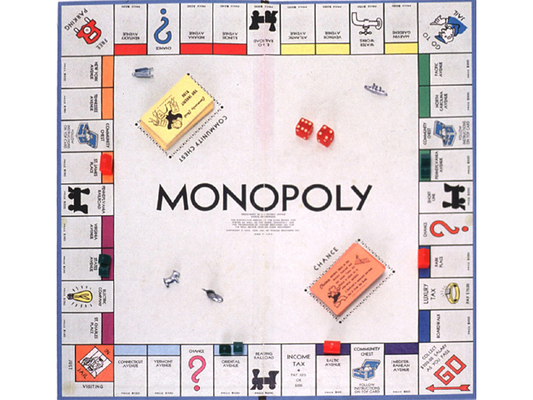
- Make sure the game is easy to understand and can be played in class

Magazine
Create a magazine themed around a particular president (People or Time, for example). You will need to….

- Create a magazine in the appropriate format with a cover page, table of contents, articles, pictures, and advertisements
- Write articles that address the required information on the president
- Include photos of the president and his term in office
- Ads should be historically appropriate
- Magazine should be at least 8 pages (EXCLUDING cover and back)

Topics to choose from:
Choose any president from Washington to Obama

Required information to include:
--Biographical information on the president (where was he born? When? Career? Family? Hobbies?)
--Overview of the history in the U.S. during his presidency (for example: if choosing Woodrow Wilson, I would expect you to focus not only on Wilson’s biographical information, but also spend a great deal of time talking about WWI and how he was involved in it)
--His biggest accomplishment as president
--His biggest failure
--A picture of the president

**For both project choices, you will be graded on INCLUSION OF ALL REUIRED MATERIAL, ACCURACY OF INFORMATION, PARTICIPATION IN YOUR GROUP, CREATIVITY, and NEATNESS.
**For both projects, you must be COMPREHENSIVE in your treatment of the topic, meaning that you should address the WHOLE presidency, not just one fact or event.

