April 1st, 2013
Entry Task Question: Write down what you will get done in the lab today
Agenda:
- Head’s up: FINAL DRAFTS DUE THIS FRIDAY!! (if you are going to be gone on Friday, you MUST turn in your final draft BEFORE Spring Break)
- Peer edit rough drafts (if not done on Friday)
- LAB DAY
Learning Targets:
--Effectively use MLA format in a research paper

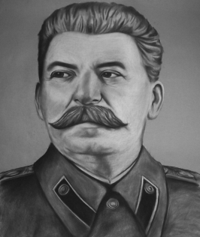
April 2nd, 2013
Entry Task Question: What do you know about the Soviet Union and this guy:
Agenda:
- Head’s up: FINAL DRAFTS DUE THIS FRIDAY!! (if you are going to be gone on Friday, you MUST turn in your final draft BEFORE Spring Break)
- Listen to Churchill’s “The Iron Curtain” speech
- Go over Cold War vocab
- Video on Berlin airlift http://www.youtube.com/watch?v=6dN6IM5PqYo
- Video on Berlin Wall http://www.youtube.com/watch?v=-9VKVt4yuhI
- Finish maps…turn in by tomorrow
Learning Targets:
--Effectively use MLA format in a research paper

April 3rd, 2013
Entry Task Question: In what ways did the U.S. attempt to prevent the spread of communism?
Agenda:
- Head’s up: FINAL DRAFTS DUE THIS FRIDAY!! (if you are going to be gone on Friday, you MUST turn in your final draft BEFORE Spring Break)
- Turn in Cold War maps
- Research paper checklist (FOR YOU ONLY, NOT TO BE TURNED IN)
- Go over quizzes from last week
- Missing assignments and time to work on them
- Also…this cool video about the presidents: http://www.youtube.com/watch?v=2Kiq_7cUhqM
Learning Targets:
--Effectively use MLA format in a research paper

April 3rd, 2013
Entry Task Question: LIBRARY DAY
Agenda:
- Head’s up: FINAL DRAFTS DUE TOMORROW!!! (if you are going to be gone on Friday, you MUST turn in your final draft BEFORE Spring Break)
Learning Targets:
--Effectively use MLA format in a research paper

April 5th, 2013
Entry Task Question: What are your plans for Spring Break?
Agenda:
- FINAL DRAFTS DUE TODAY!!
- Discuss turnitin.com requirements
- On the back of your entry task…tell me a few things you want to learn next quarter from US History
- Extra credit game OR Cold War Video
Learning Targets:
--Effectively use MLA format in a research paper

