Elizabeth Watts (Georgia 1838)
The soldiers gathered them up, all up, and put them in camps. They hunted them and ran them down until they got all of them. Even before they were loaded in wagons, many of them got sick and died. They were all grief stricken they lost all on earth they had. White men even robbed their dead’s graves to get their jewelry and other little trinkets. They saw to stay was impossible and Cherokees told Gen. Scott they would go without further trouble and the long journey started. They did not all come at once. First one batch and then another. The sick, old, and babies rode on the grub and household wagons. The rest rode a horse, if they had one. Most of them walked. Many of them died along the way. They buried them where they died, in unmarked graves. It was a bitter dose and lingered in the mind of Mrs. Watts' Grandparents and parents until death took them. The road they traveled, history calls the "Trail of Tears". This trail was more than tears. It was death, sorrow, hunger, exposure, and humiliation to a civilized people as were the Cherokees.

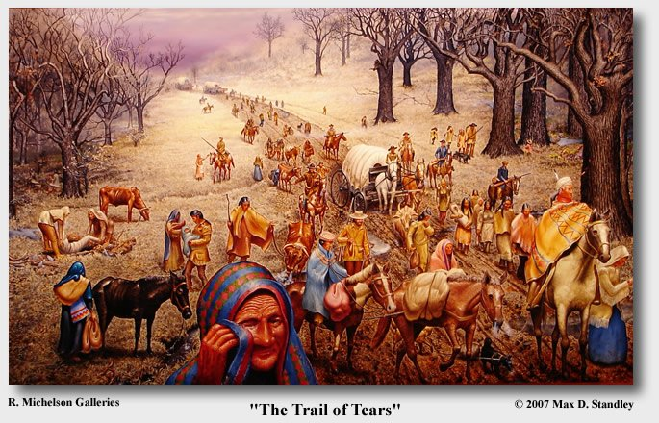

Frederick Douglass “The Right to Criticize American Institutions”

May 11, 1847
Speech before the American Anti-Slavery Society

I cannot agree with my friend Mr. Garrison, in relation to my love and attachment to this land. I have no love for America, as such; I have no patriotism. I have no country. What country have I? The institutions of this country do not know me, do not recognize me as a man. I am not though of, spoken of, in any direction, out of the anti-slavery ranks, as a man. I am not thought of, or spoken of, except as a piece of property belonging to some Christian slaveholder, and all the religious and political institutions of this country, alike pronounce me a slave and a chattel. Now, in such a country as this, I cannot have patriotism. The only thing that links me to this land is my family, and the painful consciousness that here and there are three millions of my fellow-creatures, groaning beneath the iron rod of the worst despotism that could be devised, even in Pandemonium; that here are men and brethren, who are identified with me by their complexion, identified with me by their hatred of Slavery, identified with me by their love and aspirations for liberty, identified with me by the stripes upon their backs, their inhuman wrongs and cruel sufferings. This, and this only, attaches me to this land, and brings me here to plead with you, and with this country at large, for the disenthralment of my oppressed countrymen, and to overthrow this system of Slavery which is crushing them to the earth.

The following is an excerpt from President Andrew Jackson's First Annual Message, delivered in 1829.

The condition and ulterior destiny of the Indian tribes within the limits of some of our States have become objects of much interest and importance. It has long been the policy of Government to introduce among them the arts of civilization, in the hope of gradually reclaiming them from a wandering life. This policy has, however, been coupled with another wholly incompatible with its success. Professing a desire to civilize and settle them, we have at the same time lost no opportunity to purchase their lands and thrust them farther into the wilderness. By this means they have not only been kept in a wandering state, but been led to look upon us as unjust and indifferent to their fate. Thus, though lavish in its expenditures upon the subject, Government has constantly defeated its own policy, and the Indians in general, receding farther and farther to the west, have retained their savage habits…

As a means of effecting this end I suggest for your consideration the propriety of setting apart an ample district west of the Mississippi, and without the limits of any State or Territory now formed, to be guaranteed to the Indian tribes as long as they shall occupy it, each tribe having a distinct control over the portion designated for its use. There they may be secured in the enjoyment of governments of their own choice, subject to no other control from the United States than such as may be necessary to preserve peace on the frontier and between the several tribes. There the benevolent may endeavor to teach them the arts of civilization, and, by promoting union and harmony among them, to raise up an interesting commonwealth, destined to perpetuate the race and to attest the humanity and justice of this Government.
This emigration should be voluntary, for it would be as cruel as unjust to compel the aboriginies to abandon the graves of their fathers and seek a home in a distant land.

Henry David Thoreau Civil Disobedience 1849
The authority of government, even such as I am willing to submit to — for I will cheerfully obey those who know and can do better than I, and in many things even those who neither know nor can do so well — is still an impure one: to be strictly just, it must have the sanction and consent of the governed. It can have no pure right over my person and property but what I concede to it. The progress from an absolute to a limited monarchy, from a limited monarchy to a democracy, is a progress toward a true respect for the individual…Is a democracy, such as we know it, the last improvement possible in government? Is it not possible to take a step further towards recognizing and organizing the rights of man? There will never be a really free and enlightened State until the State comes to recognize the individual as a higher and independent power, from which all its own power and authority are derived, and treats him accordingly. I please myself with imagining a State at last which can afford to be just to all men, and to treat the individual with respect as a neighbor; which even would not think it inconsistent with its own repose if a few were to lie aloof from it, not meddling with it, nor embraced by it, who fulfilled all the duties of neighbors and fellow men. A State which bore this kind of fruit, and suffered it to drop off as fast as it ripened, would prepare the way for a still more perfect and glorious State, which I have also imagined, but not yet anywhere seen.

Monroe Doctrine 1823
The Government of the United States has been desirous by this friendly proceeding of manifesting the great value which they have invariably attached to the friendship of the Emperor and their solicitude to cultivate the best understanding with his Government. In the discussions to which this interest has given rise and in the arrangements by which they may terminate the occasion has been judged proper for asserting, as a principle in which the rights and interests of the United States are involved, that the American continents, by the free and independent condition which they have assumed and maintain, are henceforth not to be considered as subjects for future colonization by any European powers. . .

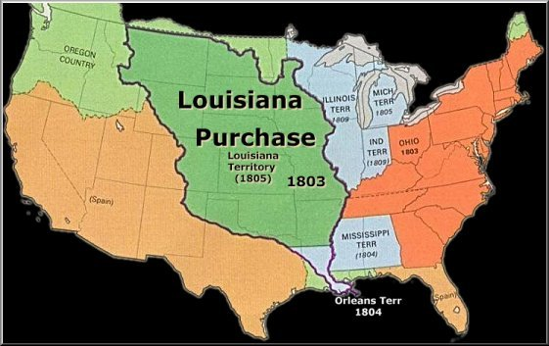

A Letter from President Thomas Jefferson to Captain Meriwether Lewis:

June 1803 To Meriwether Lewis esq. Capt. of the 1st regimt. of infantry of the U. S. of A. The object of your mission is to explore the Missouri River and other rivers to find a water route to the Pacific Ocean for the purpose of trade. You should make detailed notes throughout your journey, and make several copies of the notes. Choose the most trustworthy individuals to care for them. Make careful observations of latitude and longitude at all points on the river, especially at the mouths of rivers and other important places. We want to make new maps of the area. Plan to meet the Indian tribes and to begin trade with them. We want to know many things about the people you meet, including their tribe names, how many people are in each tribe, their languages and traditions, their occupations, any diseases they have and remedies they use, and the things they might need or offer in trade. Be sure to treat the natives in the friendliest manner that you are able. You should also notice and record information about new plants and animals that you observe and the minerals you find. Also record what the climate and landscape are like. Return the way you came and confirm the observations that you made on the way out.

Report of the Woman's Rights Convention, Held at Seneca Falls, N.Y., July 19th and 20th, 1848

Resolved, That such laws as conflict, in any way, with the true and substantial happiness of woman, are contrary to the great precept of nature, and of no validity; for this is "superior in obligation to any other.
Resolved, That all laws which prevent woman from occupying such a station in society as her conscience shall dictate, or which place her in a position inferior to that of man, are contrary to the great precept of nature, and therefore of no force or authority.
Resolved, That woman is man's equal—was intended to be so by the Creator, and the highest good of the race demands that she should be recognized as such.
Resolved, That the women of this country ought to be enlightened in regard to the laws under which they –live…
Resolved, That inasmuch as man, while claiming for himself intellectual superiority, does accord to woman moral superiority, it is pre-eminently his duty to encourage her to speak, and teach, as she has an opportunity, in all religious assemblies.
We hold these truths to be self-evident: that all men and women are created equal…

“On the Constitution and the Union”

William Lloyd Garrison
December 29, 1832

People of New-England, and of the free States! is it true that slavery is no concern of yours? Have you no right even to protest against it, or to seek its removal? Are you not the main pillars of its support? How long do you mean to be answerable to God and the world, for spilling the blood of the poor innocents? Be not afraid to look the monster SLAVERY boldly in the face. He is your implacable foe—the vampire who is sucking your life-blood—the ravager of a large portion of your country, and the enemy of God and man. Never hope to be a united, or happy, or prosperous people while he exists. He has an appetite like the grave—a spirit as malignant as that of the bottomless pit—and an influence as dreadful as the corruption of death. Awake to your danger! the struggle is a mighty one—it cannot be avoided—it should not be, if it could.
It is said that if you agitate this question, you will divide the Union. Believe it not; but should disunion follow, the fault will not be yours. You must perform your duty, faithfully, fearlessly and promptly, and leave the consequences to God: that duty clearly is, to cease from giving countenance and protection to southern kidnappers. Let them separate, if they can muster courage enough—and the liberation of their slaves is certain. Be assured that slavery will very speedily destroy this Union, if it be let alone; but even if the Union can be preserved by treading upon the necks, spilling the blood, and destroying the souls of millions of your race, we say it is not worth a price like this, and that it is in the highest degree criminal for you to continue the present compact. Let the pillars thereof fall—let the superstructure crumble into dust—if it must be upheld by robbery and oppression.

