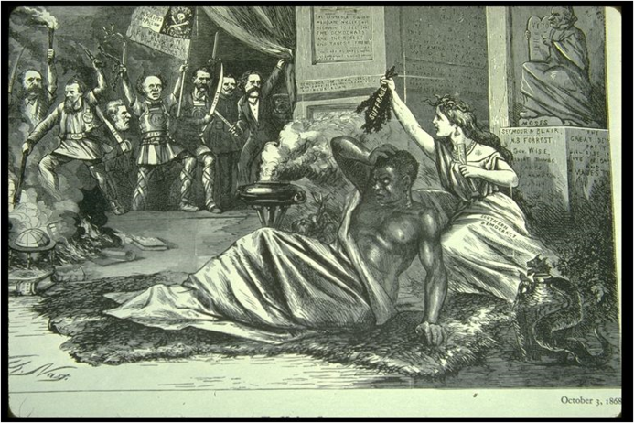
- Describe what is going on in this cartoon
- Is this cartoon in favor of Reconstruction?
  - How do you know?
- What message is the cartoonist trying to send about Reconstruction?
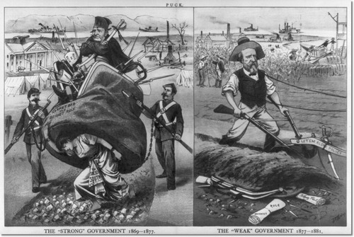
- Describe what is going on in this cartoon
- Is this cartoon in favor of Reconstruction?
  - How do you know?
- What message is the cartoonist trying to send about Reconstruction?

