Read the summary of the battle. You will create a newspaper headline on the poster paper provided. Your newspaper should have a headline that highlights the battle, a picture to represent your battle, and a summary of the battle that includes the following points:

--Major military leaders involved

--Geographic location

--Key strategies

--Outcome (who won)

--Importance of the battle (lasting impact on the war, casualty numbers, was it a turning point? Etc…)

Your poster should be NEAT, CREATIVE, and ACCURATE

Battle of Antietam
Sharpsburg
September 16 - 18, 1862
WASHINGTON COUNTY, MARYLAND
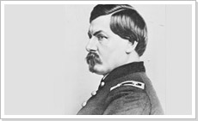On September 16, 1862, Maj. Gen. George B. McClellan and his Union Army of the Potomac confronted Robert E. Lee’s Army of Northern Virginia at Sharpsburg, Maryland. At dawn on September 17, Maj. General Joseph Hooker’s Union corps mounted a powerful assault on Lee’s left flank that began the Battle of Antietam, and the single bloodiest day in American military history. Repeated Union attacks, and equally vicious Confederate counterattacks, swept back and forth across Miller’s cornfield and the West Woods. Despite the great Union numerical advantage, Stonewall Jackson’s forces near the Dunker Church would hold their ground this bloody morning. Meanwhile, towards the center of the battlefield, Union assaults against the Sunken Road would pierce the Confederate center after a terrible struggle for this key defensive position. Unfortunately for the Union army this temporal advantage in the center was not followed up with further advances.
Late in the day, Maj. General Ambrose Burnside’s corps pushed across a bullet-strewn stone bridge over Antietam Creek and with some difficulty managed to imperil the Confederate right. At a crucial moment, A.P. Hill’s division arrived from Harpers Ferry, and counterattacked, driving back Burnside and saving the day for the Army of Northern Virginia. Despite being outnumbered two-to-one, Lee committed his entire force at the Battle of Antietam, while McClellan sent in less than three-quarters of his Federal force. McClellan’s piecemeal approach to the battle failed to fully leverage his superior numbers and allowed Lee to shift forces from threat to threat. During the night, both armies tended to their wounded and consolidated their lines. In spite of crippling casualties, Lee continued to skirmish with McClellan on the 18th, while removing his wounded south of the Potomac. McClellan, much to the chagrin of Abraham Lincoln, did not vigorously pursue the wounded Confederate army. While the Battle of Antietam is considered a draw from a military point of view, Abraham Lincoln and the Union claimed victory. This hard-fought battle, which drove Lee’s forces from Maryland, 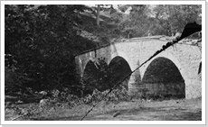would give Lincoln the “victory” that he needed before delivering the Emancipation Proclamation — a document that would forever change the geopolitical course of the American Civil War.

Battle of Gettysburg
July 1 - 3, 1863
ADAMS COUNTY, PENNSYLVANIA
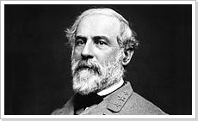
After his astounding victory an the Battle of Chancellorsville, Virginia, in May 1863, Lee led his Army of Northern Virginia in its second invasion of the North—the Gettysburg Campaign. With his army in high spirits, Lee intended to collect supplies in the abundant Pennsylvania farmland and take the fighting away from war-ravaged Virginia. He wanted to threaten Northern cities, weaken the North's appetite for war and, especially, win a major battle on Northern soil and strengthen the peace movement in the North. Prodded by President Abraham Lincoln, Maj. Gen. Joseph Hooker moved his Union Army of the Potomac in pursuit, but was relieved of command just three days before the battle. Hooker's successor, Maj. Gen. George Gordon Meade moved northward, keeping his army between Lee and Washington, D.C. When Lee learned that Meade was in Pennsylvania, Lee concentrated his army around Gettysburg.
Elements of the two armies collided west and north of the town on July 1, 1863. Union cavalry under Brig. Gen. John Buford slowed the Confederate advance until Union infantry, the Union 1st and 11th Corps, arrived. More Confederate reinforcements under generals A.P. Hill and Richard Ewell reached the scene, however, and 30,000 Confederates ultimately defeated 20,000 Yankees, who fell back through Gettysburg to the hills south of town--Cemetery Hill and Culp's Hill.
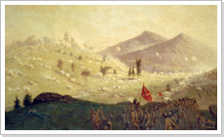
On the second day of battle, the Union defended a fishhook-shaped range of hills and ridges south of Gettysburg with around 90,000 soldiers. Confederates essentially wrapped around the Union position with 70,000 soldiers. On the afternoon of July 2, Lee launched a heavy assault on the Union left flank, and fierce fighting raged at Devil's Den, Little Round Top, the Wheatfield, the Peach Orchard and Cemetery Ridge. On the Union right, demonstrations escalated into full-scale assaults on Culp's Hill and East Cemetery Hill. Although the Confederates gained ground, the Union defenders still held strong positions by the end of the day.
On July 3, fighting resumed on Culp's Hill, and cavalry battles raged to the east and south, but the main event was a dramatic infantry assault by 12,000 Confederates against the center of the Union line on Cemetery Ridge--Pickett's Charge. The charge was repulsed by Union rifle and artillery fire, at great losses to the Confederate army. Lee led his army on a torturous retreat back to Virginia. As many as 51,000 soldiers from both armies were killed, wounded, captured or missing in the three-day battle. Four months after the battle, President Lincoln used the dedication ceremony for Gettysburg's Soldiers National Cemetery to honor the fallen Union soldiers and redefine the purpose of the war in his historic Gettysburg Address.

Fort Sumter
April 12 - 14, 1861
CHARLESTON HARBOR, SOUTH CAROLINA
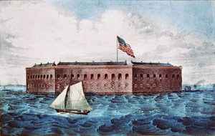When South Carolina seceded from the Union on December 20, 1860, United States Maj. Robert Anderson and his force of 85 soldiers were positioned at Fort Moultrie near the mouth of Charleston Harbor. On December 26, fearing for the safety of his men, Anderson moved his command to Fort Sumter, an imposing fortification in the middle of the harbor. While politicians and military commanders wrote and screamed about the legality and appropriateness of this provocative move, Anderson’s position became perilous. Just after the inauguration of President Abraham Lincoln on March 4, 1861, Anderson reported that he had only a six week supply of food left in the fort and Confederate patience for a foreign force in its territory was wearing thin.
On Thursday, April 11, 1861, Confederate Brig. Gen. P.G.T. Beauregard dispatched aides to Maj. Anderson to demand the fort’s surrender. Anderson refused. The next morning, at 4:30 a.m., Confederate batteries opened fire on Fort Sumter and continued for 34 hours. The Civil War had begun! Anderson did not return the fire for the first two hours. The fort's supply of ammunition was not suited for an equal fight and Anderson lacked fuses for his exploding shells--only solid shot could be used against the Rebel batteries. At about 7:00 A.M., Union Capt. Abner Doubleday, the fort's second in command, was afforded the honor of firing the first shot in defense of the fort.
The firing continued all day, although much less rapidly since the Union fired aimed to conserve ammunition. "The crashing of the shot, the bursting of the shells, the falling of the walls, and the roar of the flames, made a pandemonium of the fort," wrote Doubleday. The fort's large flag staff was struck and the colors fell to the ground and a brave lieutenant, Norman J. Hall, bravely exposed himself to enemy fire as he put the Stars and Stripes back up. That evening, the firing was sporadic with but an occasional round landing on or in Fort Sumter.
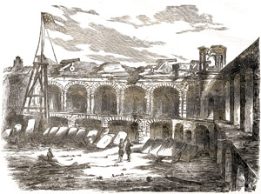On Saturday, April 13, Anderson surrendered the fort. Incredibly, no soldiers were killed in battle. The generous terms of surrender, however, allowed Anderson to perform a 100-gun salute before he and his men evacuated the fort the next day. The salute began at 2:00 P.M. on April 14, but was cut short to 50 guns after an accidental explosion killed one of the gunners and mortally wounded another. Carrying their tattered banner, the men marched out of the fort and boarded a boat that ferried them to the Union ships outside the harbor. They were greeted as heroes on their return to the North.

First Battle of Bull Run
First Manassas
July 21, 1861
FAIRFAX COUNTY AND PRINCE WILLIAM COUNTY , VIRGINIA
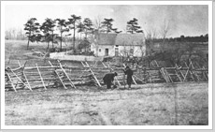Though the Civil War began when Confederate troops shelled Fort Sumter on April 12, 1861, the war didn’t begin in earnest until the Battle of Bull Run, fought in Virginia just miles from Washington DC, on July 21, 1861. Popular fervor led President Lincoln to push a cautious Brigadier General Irvin McDowell, commander of the Union army in Northern Virginia, to attack the Confederate forces commanded by Brigadier General P.G.T. Beauregard, which held a relatively strong position along Bull Run, just northeast of Manassas Junction. The goal was to make quick work of the bulk of the Confederate army, open the way to Richmond, the Confederate capital, and end the war.
The morning of July 21st dawned on two generals planning to outflank their opponent’s left. Hindering the success of the Confederate plan were several communication failures and general lack of coordination between units. McDowell’s forces, on the other had, were hampered by an overly complicated plan that required complex synchronization. Constant and repeated delays on the march and effective scouting by the Confederates gave his movements away, and, worst of all Patterson failed to occupy Johnston’s Confederate forces attention in the west. McDowell’s forces began by shelling the Confederates across Bull Run. Others crossed at Sudley Ford and slowly made their way to attack the Confederate left flank. At the same time as Beauregard sent small detachments to handle what he thought was only a distraction, he also sent a larger contingent to execute flanking a flanking movement of his own on the Union left.
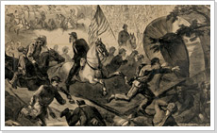Fighting raged throughout the day as Confederate forces were driven back, despite impressive efforts by Colonel Thomas Jackson to hold important high ground at Henry House Hill, earning him the nom de guerre “Stonewall.” Late in the afternoon, Confederate reinforcements including those arriving by rail from the Shenandoah Valley extended the Confederate line and succeeded in breaking the Union right flank. At the battle’s climax Virginia cavalry under Colonel James Ewell Brown “Jeb” Stuart arrived on the field and charged into a confused mass of New Yorkers, sending them fleetly to the rear. The Federal retreat rapidly deteriorated as narrow bridges, overturned wagons, and heavy artillery fire added to the confusion. The calamitous retreat was further impeded by the hordes of fleeing onlookers who had come down from Washington to enjoy the spectacle. Although victorious, Confederate forces were too disorganized to pursue. By July 22, the shattered Union army reached the safety of Washington. The Battle of Bull Run convinced the Lincoln administration and the North that the Civil War would be a long and costly affair. McDowell was relieved of command of the Union army and replaced by Maj. Gen. George B. McClellan, who set about reorganizing and training the troops.

Battle of Shiloh
Pittsburg Landing
April 6 - 7, 1862
HARDIN COUNTY, TENNESSEE
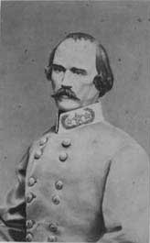
Following fall of Forts Henry and Donelson in February of 1862, the commander of Confederate forces in the West, Gen. Albert Sidney Johnston, was compelled to withdraw from Kentucky, and leave much of western and middle Tennessee to the Federals. To prepare for future offensive operations, Johnston marshalled his forces at Corinth, Mississippi—a major transportation center. The Confederate retreat was a welcome surprise to Union commander Maj. Gen. Ulysses S. Grant, whose Army of the Tennessee would need time to prepare for its own offensive along the Tennessee river. Grant's army made camp at Pittsburg Landing where it spent time drilling raw recruits and awaiting reinforcements in the form of Maj. Gen. Don Carlos Buell’s Army of the Ohio. Johnston needed to strike Grant at Pittsburg Landing before the two Federal armies could unite.
Aware of Grant's location and strength—and that more Yankees were on the way—Johnston originally planned to attack the unfortified Union position on April 4, but weather and other logistical concerns delayed the attack until April 6. The Confederate's morning assault completely surprised and routed many of the unprepared Northerners. By afternoon, the a few stalwart bands of Federals established a battle line along a sunken road, known as the “Hornets Nest.” After repeated attempts to carry the position, the Rebels pounded the Yankees with massed artillery, and ultimately surrounded them. Later in the day Federals established a defensive line covering Pittsburg Landing, anchored with artillery and augmented by Buell’s men, who had begun to arrive. Fighting continued until after dark, but the Federals held. Though they had successfully driven the Yankees back, there was, however, one significant blow to the Confederate cause on April 6. Johnston had been mortally wounded early during the day and command of the Confederate force fell to Gen. P.G.T. Beauregard.
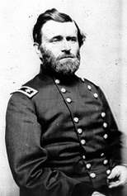With the addition of Buell's men, the Federal force of around 40,000 outnumbered Beauregard’s army of fewer than 30,000. Beauregard, however, was unaware of Buell’s arrival. Therefore, when William Nelson’s division of Buell’s army launched an attack at 6:00 am on April 7, Beauregard immediately ordered a counterattack. Though Beauregard's counter thrust was initially successful, Union resistance stiffened and the Confederates were compelled to fall back and regroup. Beauregard ordered a second counterattack, which halted the Federals' advance but ultimately ended in stalemate. By this point, Beauregard realized he was outnumbered and, having already suffered tremendous casualties, broke contact with the Yankees to began a retreat to Corinth.

Battle of Chancellorsville
April 30 - May 6, 1863
SPOTSYLVANIA COUNTY, VIRGINIA
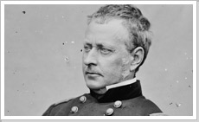General Ambrose E. Burnside only lasted a single campaign at the head of the Army of the Potomac. His abject failure at Fredericksburg, followed by further fumbling on January's "Mud March," convinced President Abraham Lincoln to make a change.
Hooker's energetic make-over polished the Northern army into tip-top condition, and with more strength than ever before. The army commander outmaneuvered Lee in late April, when the weather finally allowed roads to harden enough for marching.
Swinging far beyond Lee's left, Hooker closed up on the Chancellorsville intersection on the last evening in April. He never managed to escape the clutches of the Wilderness, though—the tangled, brush-choked thickets that covered about 70 square miles around Chancellorsville.
On May 1, Lee hurriedly gathered his army from its far-flung camps across the Old Dominion. He used his regiments to hem the quiescent Hooker into the Wilderness, pushing west along the two primary corridors in the region—the Orange Turnpike and the Orange Plank Road.
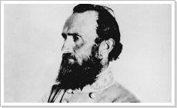
That evening Lee and his incomparable lieutenant, Stonewall Jackson, conceived their greatest, and last, collaboration. Early on May 2 Jackson took nearly 30,000 men off on a march that clandestinely crossed the front of the enemy army and swung around behind it. That left Lee with only about 15,000 men to hold off Hooker's army. He managed that formidable task by feigning attacks with a scant line of skirmishers.
Soon after 5 p.m. Jackson, having completed his circuit around the enemy, unleashed his men in an overwhelming attack on Hooker's right flank and rear. They shattered the Federal Eleventh Corps and pushed the Northern army back more than two miles.
When Jackson's men burst out of the thickets screaming the Rebel Yell that afternoon, they dashed across the high-water mark of the Army of Northern Virginia. About three hours later the army suffered a nadir as low as the afternoon's zenith, when Jackson fell mortally wounded by the mistaken fire of his own men.
The long marches, high risks, and veiled stratagems of May 1-2 gave way on the 3rd to a slugging match in the woods on three sides of Chancellorsville intersection. Hooker abandoned key ground in a further display of timidity; Confederate artillery roared from a crucial hilltop, employing a brand-new battalion organization; and Southern infantry doggedly pushed ahead.
When a Confederate artillery round smashed into a pillar against which Hooker was leaning, the Federal leader spent an unconscious half hour. His return to semi-sentience disappointed the veteran corps commanders who had hoped, unencumbered by Hooker, to employ their army's considerable untapped might.
By mid-morning, Southern infantry smashed through the final resistance and united in the Chancellorsville clearing. Their boisterous, well-earned, celebration did not run long: word came from the direction of Fredericksburg that a Northern rearguard had broken through and threatened the rear.
The May 3 Battle of Salem Church, just west of Fredericksburg, halted the threat from the east. Lee went to that zone in person to ensure final success on the 4th, then returned to Chancellorsville to superintend the corralling of Hooker's defeated army.
Hooker re-crossed the Rappahannock River to its left bank, whence he had come, early on May 6. The campaign had cost him about 18,000 casualties, and his enemy about 13,000. None of the losses on either side would resonate as loudly and long as the death of Stonewall Jackson.

